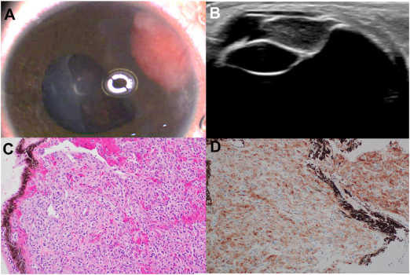

A, Examination revealed peripheral amelanotic vascular lesion with a largerretrolenticular portion. B, Ultrasound demonstrated a homogenous mass arising from the ciliary body (CB). The patient underwentexcisional biopsy through a scleral tunnel incision. C, Pathology showed a low-grade neoplasm with plump epithelioid cells. Immunohistochemistry showed diffuse expression of HMB45 immunostain (D) and heterogeneous smooth muscle actin (SMA), while beingnegative for SOX10 and S100. On RNA sequencing PRCC-TFE3 fusion was detected. Based on the provided images and clinical description please make an ophthalmic diagnosis for this patient. And output the diagnostic conclusions only.

**Perivascular epithelioid cell tumor (PEComa) of the ciliary body.**